Consejería de Educación y Deporte

Information Sheet for LANGUAGE Assistants
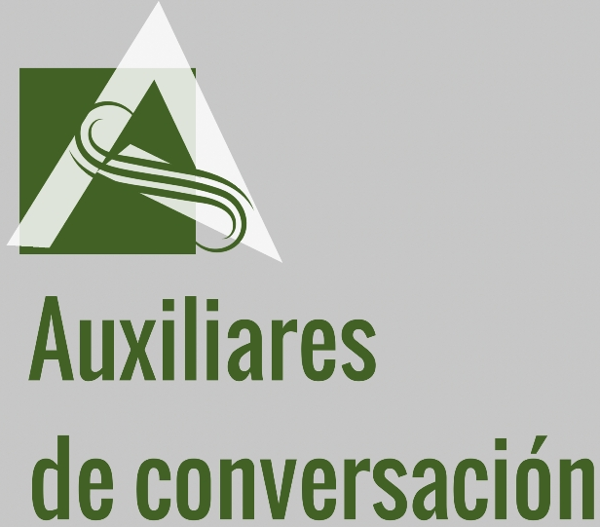

SCHOOL DATA | - School name: CPIFP José Luis Graiño  - Full address: Av de la Rábida s/n  - Telephone number: 959656127  - Email: correo@profesorjlg.es  - Location link on Google Maps: https://goo.gl/maps/q8Pk5wHdPtbZYEgf8
Contact of the reference person(s) | - Email of a member of the management team: direccion@profesorjlg.es  - Email of the teacher coordinating the program: lmedel2@hotmail.com
Education level | - Vocational Training school (age: 16-)
Collaboration subjects/modules of the Language Assistant | The collaboration modules of the language assistant belong to the following formative cycles:  - CFGS on Chemical industry.  - CFGS on transport and logistics.  For further information visit the school web page:  https://www.profesorjoseluisgraiño.es
Information about the town and/or neighborhood | - The school is located between “Palos de la Frontera” village, and “Huelva” city. There are buses that connect the school with both places, Palos and Huelva. Huelva is bigger than Palos and offers a variety of activities, places to visit and to live.  Nature is beautiful in Huelva, which is surrounded by pine forests and beaches; There are mountains with picturesque villages not far from the city.  Complete information about Huelva is available in the following web page:  https://turismo.huelva.es
Getting to school | It is possible to live in Huelva or in Palos de la Frontera to get to the school.  - Link to the website of public transport company. https://damas-sa.es  Adress: Av. Doctor Rubio s/n Huelva  Schedule:  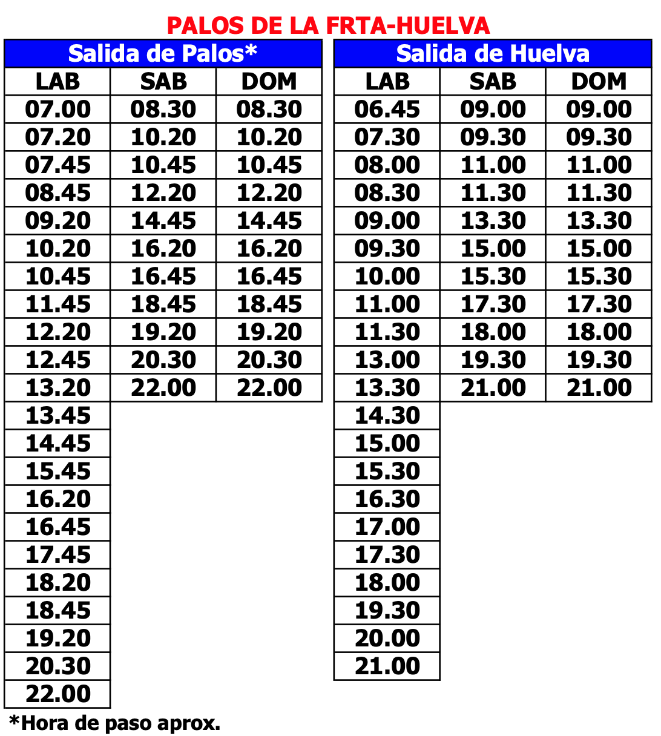
Accommodation  - Where to live in town?  - Possibility of sharing a flat with teachers? | To book a room provisionally: http://www.inturjoven.com/albergues/huelva/albergue-inturjoven-huelva  It May be that, in the meanwhile, you will contact with others language assistants and you decide to share a flat together. There are websites where you could find a flat to rent, such as:  - www.fotocasa.es  - www.idealista.es
Contact with other Language Assistants | - Huelva receive about 70 language assistants each year. It is possible to contact with others assistants in surrounding areas in order to share an apartment or to make friends.  The following web site may be also usefull for further information  http://acandalucia.weebly.com/index.html
Previous Experiences with Language Assistants | https://velazquezbilingue.blogspot.com/  https://blogsaverroes.juntadeandalucia.es/plurilinguismodelegacionhuelva/auxiliares-de-conversacion-la-colaboracion-en-la-ensenanza-bilingue-continua-ii/  http://www.isabelperez.com/clil.htm#what  https://www.juntadeandalucia.es/educacion/portals/web/plurilinguismo

